BEST

Wireframe, Layouts, Visual hierarchy

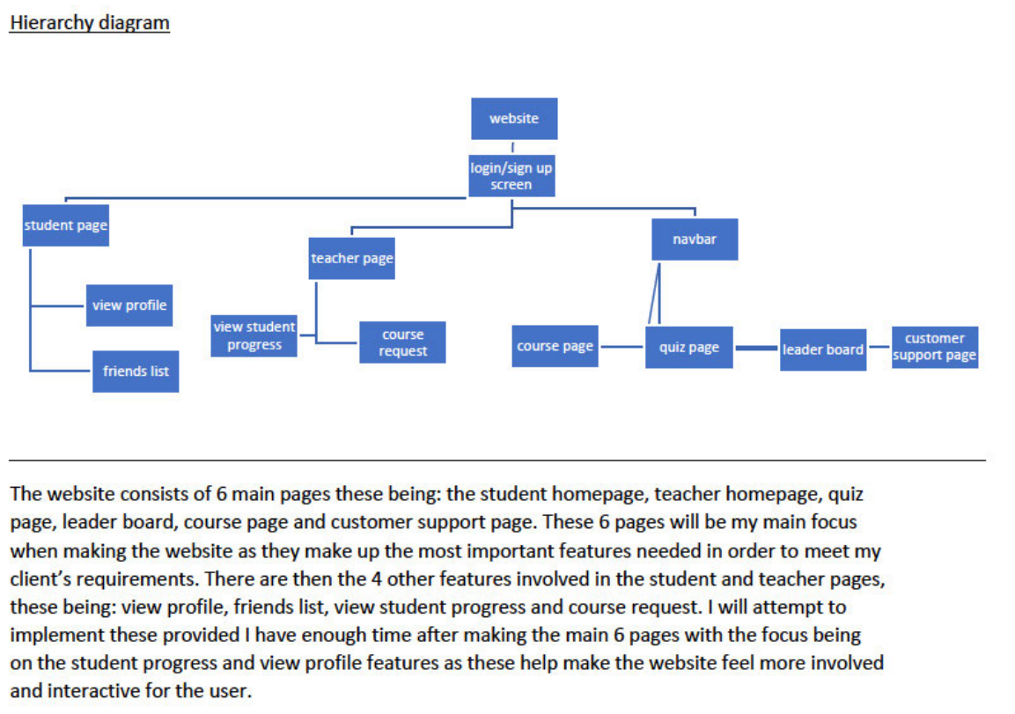

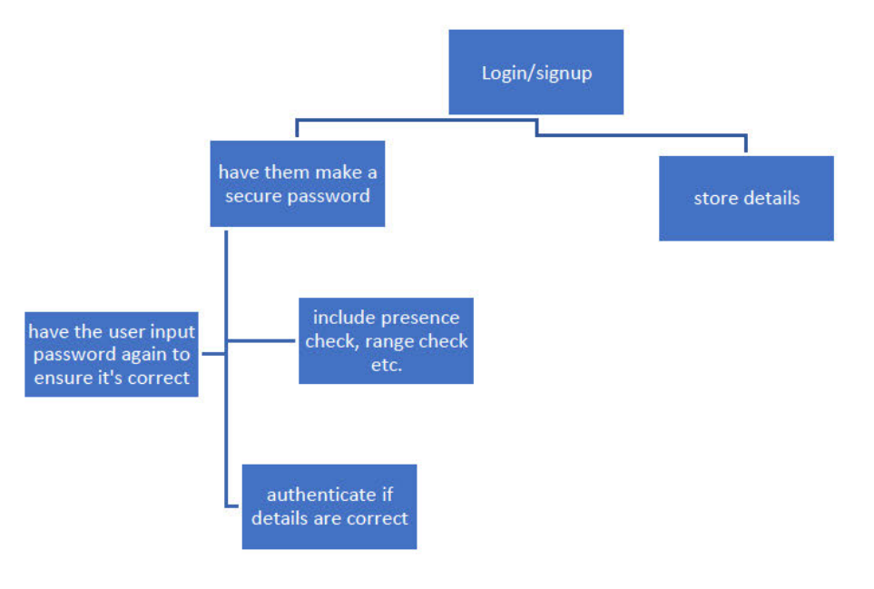

This is the breakdown of the components in signing up or logging into the website, the two parts to this component are storing the details which will store the information they input to the databaseand making the secure password which has 3 main parts to. Making sure the user actually input the information, having the user input the information again and authenticating that the password is correct.

Login screen

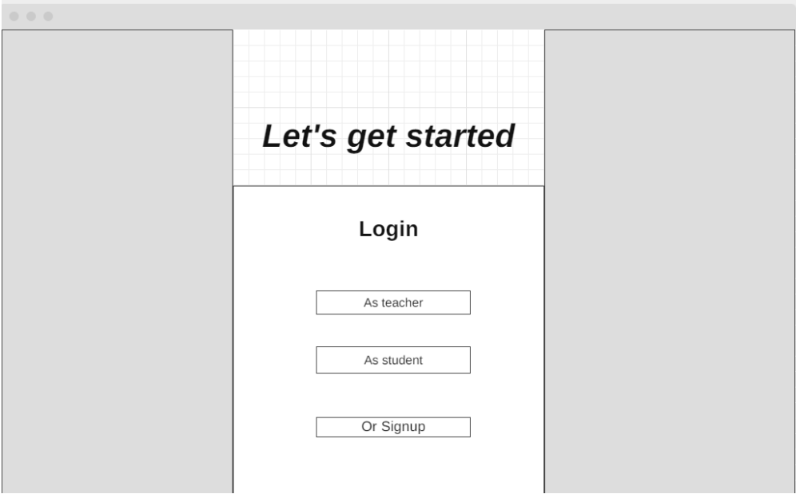

This is the layout plan for the login/signup page, I’ve made sure to keep it simple (as to avoid confusing any new user clicking onto the website) with clear buttons directing the user where they need to go. The grey boxes represent the areas on the page that I would want to put an image or have some form of a background due to this being the standard practice for many log-on screens and so would confuse the user less.